COAL LAB TASK 3A
Roll no : 24k-0954
Q 1
INCLUDE Irvine32.inc
.data
a db 10h
b db 12h
varc db 20h
d db 25h
.code
main PROC
mov al, b
add al, al
add al, varc
add al, d
movzx ebx, al
call dumpregs
exit
main ENDP
END main
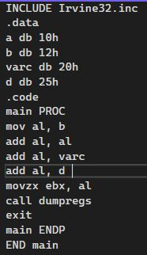
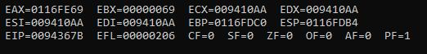
Q 2
INCLUDE Irvine32.inc

.DATA
bArray BYTE 10 DUP(0)

.CODE
main PROC
mov esi, OFFSET bArray
mov ecx, LENGTHOF bArray
fill_loop:
mov BYTE PTR [esi], 5
inc esi
loop fill_loop
exit
main ENDP
END main
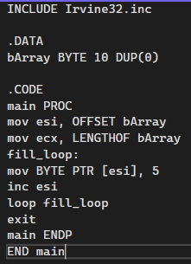

Q 3
INCLUDE Irvine32.inc

.DATA
NUCESstr BYTE 200 DUP("NUCES")

.CODE
main PROC
mov edx, OFFSET NUCESstr
call WriteString
exit
main ENDP
END main
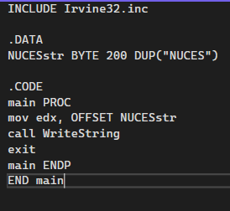
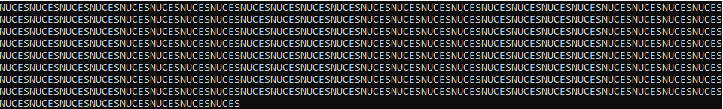

Q 4
INCLUDE Irvine32.inc

.DATA
dArray DWORD 30 DUP(?)

.CODE
main PROC
mov esi, OFFSET dArray
mov ecx, LENGTHOF dArray
mov eax, 1
fill_dArray:
mov [esi], eax
add esi, TYPE dArray
inc eax
loop fill_dArray
exit
main ENDP
END main
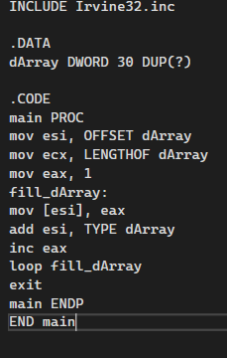

Q 5
INCLUDE Irvine32.inc

.DATA
var1 WORD 10, 20, 30

.CODE
main PROC
mov ax, var1
mov bx, var1+2
mov cx, var1+4
call DumpRegs
exit
main ENDP
END main
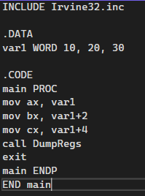
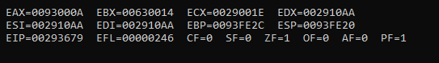

Q 6
INCLUDE Irvine32.inc
.DATA
marks WORD 5 DUP(3 DUP(?))
.CODE
main PROC
mov esi, OFFSET marks
mov ecx, LENGTHOF marks
mov ax, 50
fill_marks:
mov [esi], ax
add esi, TYPE marks
add ax, 5
loop fill_marks
exit
main ENDP
END main
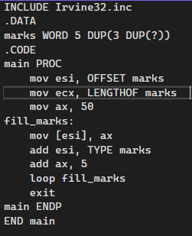

Q 7
INCLUDE Irvine32.inc
.DATA
num1 SDWORD 1000h
num2 SDWORD ?
.CODE
main PROC
mov eax, num1
mov num2, eax
call DumpRegs
exit
main ENDP
END main
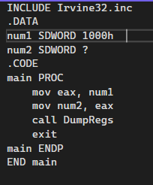
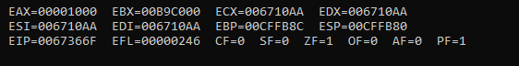

Q 8
INCLUDE Irvine32.inc

.DATA
num1 SDWORD 1000h
num2 SDWORD ?

.CODE
main PROC
mov eax, num1
mov num2, eax
call DumpRegs
exit
main ENDP
END main
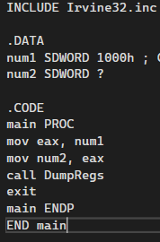
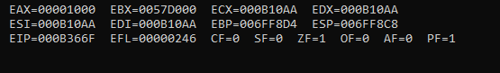

Q 9
INCLUDE Irvine32.inc
.DATA
uArray WORD 20 DUP(5)
.CODE
main PROC
mov esi, OFFSET uArray
mov ecx, LENGTHOF uArray
print_loop:
movzx eax, WORD PTR [esi]
call WriteInt
call Crlf
add esi, TYPE uArray
loop print_loop
exit
main ENDP
END main
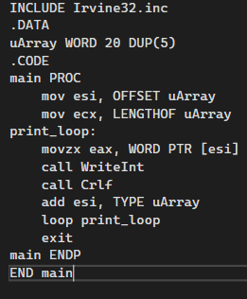
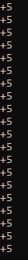
Q 10
INCLUDE Irvine32.inc
.data
msg db 100 DUP(?)
source db "COMPUTER ORGANIZATION & ASSEMBLY LANGUAGE LAB", 0
.code
main PROC
mov esi, OFFSET source
mov edi, OFFSET msg
mov ecx, LENGTHOF source
rep movsb
mov edx, OFFSET msg
call WriteString
exit
main ENDP
END main
